# Materials Used

Figure . - LPC1768 with switch, jumpers and breadboard

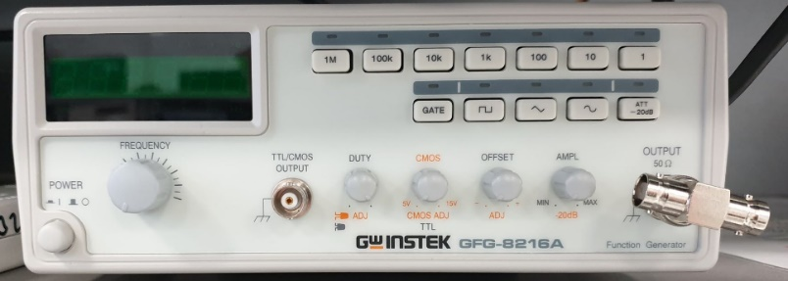

Figure . - Signal generator

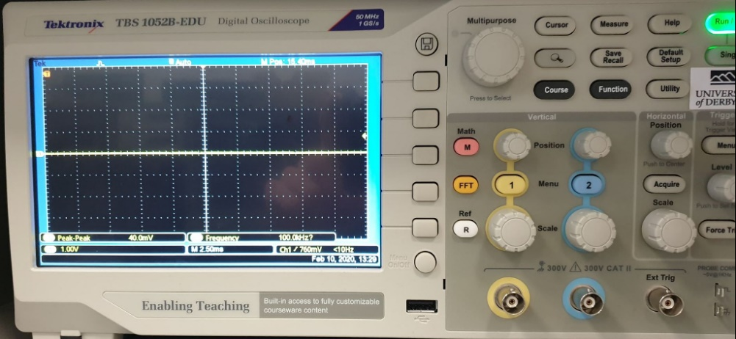

Figure . - 2 channel digital oscilloscope

Figures 1.1, 1.2 and 1.3 show the ARM MBED LPC 1768 Microcontroller, a signal generator and a digital oscilloscope. These along with BNC connectors, jumpers and a switch, were used for the different experiments in this report.

# Generating a square wave

## Methodology

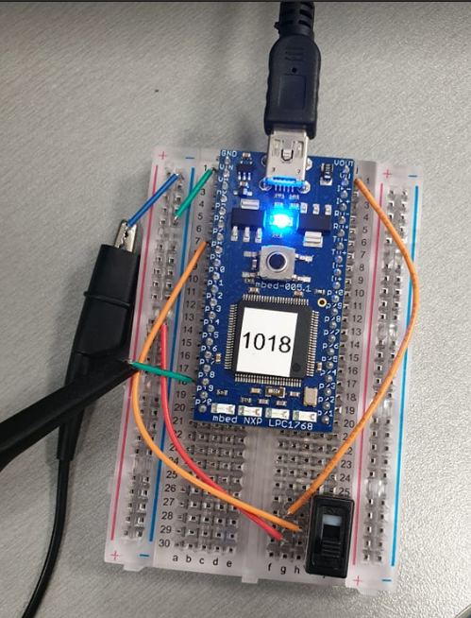

Figure shows the connections for generating a square wave. The goal of this algorithm was to generate a square wave where the frequency could be changed with the switch, between 100Hz (down position) and 200Hz (up position).

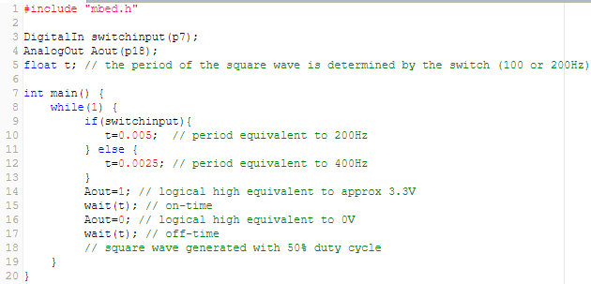

Figure shows the code to generate a square waveform. It uses a digital input pin (for the switch) and an analogue output pin (square wave voltage); viewed through the oscilloscope.

## Results and analysis

The two different periods shown in lines 10 and 12 of the code are double the desired frequency because a single period of a square wave consists of “high time” and “low time”, these can be denoted as and respectively. Eqs. (1-6) show the total period and frequency of the 100Hz square wave.

|  |  |
| --- | --- |
|  | (1) |
|  | (2) |
|  | (3) |
|  | (4) |
|  | (5) |
|  | (6) |

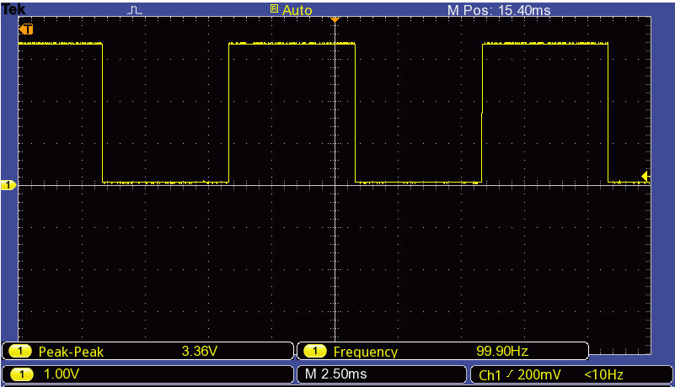

Figure shows the output square wave for when the switch is set to 100Hz (down position).

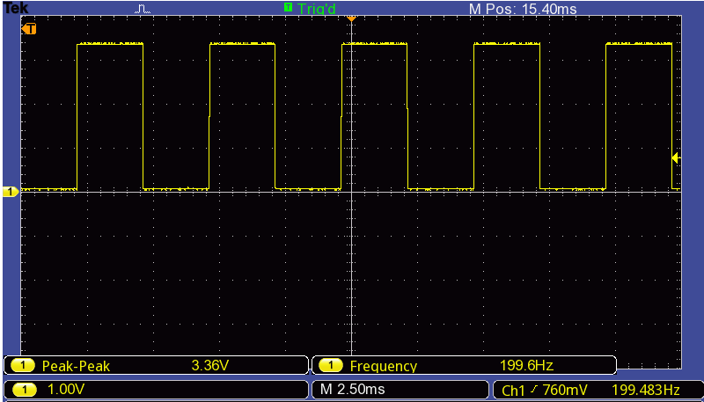

Figure shows the output square wave for when the switch is set to 200Hz (up position).

# Generating a triangle wave

## Methodology

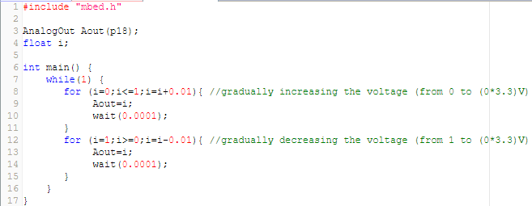

Figure shows the code to generate a triangle wave.

## Results and analysis

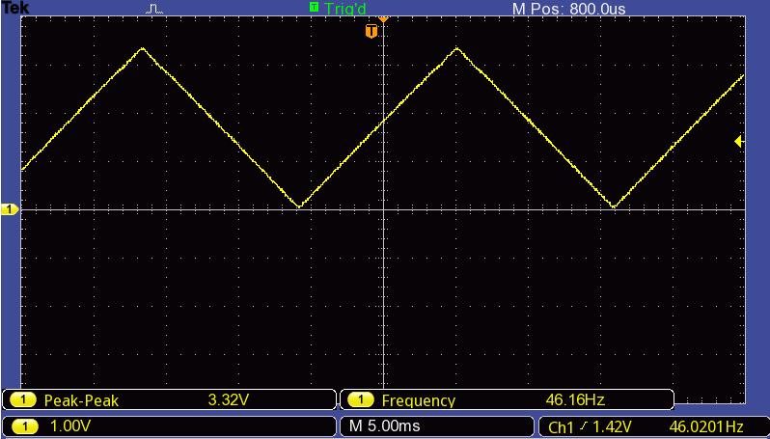

Figure shows the triangle wave generated, as the code, the maximum voltage value is 3.3V and the minimum voltage value is 0V.

# Varying the frequency of a sine wave

## Methodology

the procedure indicated in the lab guide was followed

## Results and analysis

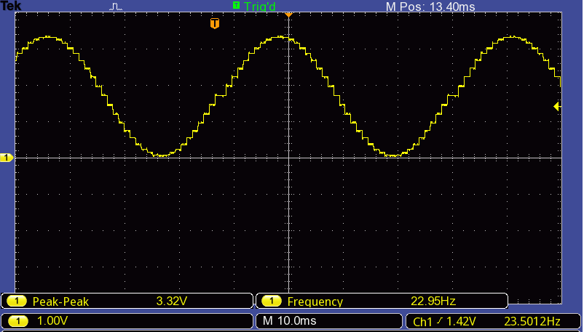

# test

## Methodology

the procedure indicated in the lab guide was followed

## Results and analysis

# Signal generator as ADC input

## Methodology

the procedure indicated in the lab guide was followed

## Results and analysis

# Bibliography

# Appendix